Portland Parks Foundation

Small Grants Program
Accepting applications for the Spring Small Grants cycle from March 1 - April 15, 2022.
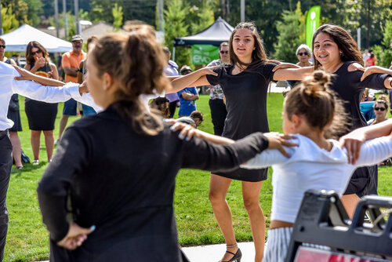
Ben Brink/Portland Parks & Recreation
The Portland Parks Foundation’s Small Grants Program awards financial support to community-based organizations within the city of Portland who foster equitable access to our urban parks, natural areas, community gardens and community recreation centers
This year PPF will support 10 projects or organizations with a $2,000 grant each. Five of those grants will be awarded in the Spring and five in the Fall of 2022.

Please contact Jessica Green at jgreen@portlandpf.org or 503-445-0994, if you have any questions about a future proposal or the grant program or would like help putting your application together.

Small Grant Program Application Form and Guidelines:
APPLICATION GUIDELINES
APPLICATION FORM

